 VINOD SIR’S GROUP TUTION

MARKS: 23 MATHS-1I TIME: 1 Hr. 30 Mins.

Q. 1: Solve the following sums: [14]
1. 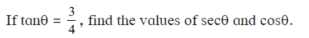 [2]
2. [3]
3. Prove that: 1. 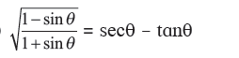 [6]
2.
4. Two buildings are facing each other on a road of width 12 metre. From the top of the first building, which is 10 metre high, the angle of elevation of the top of the second is found to be 60°. What is the height of the second building? [3]

Q. 2: Solve the following sums: [9]

1. In a cylindrical wrapper of flat tablets is shown. The radius of a tablet is 7 mm and its thickness is 5 mm. How many such tablets are wrapped in the wrapper?
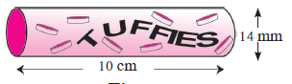

2. c PQRS is a rectangle. If PQ = 14 cm, QR = 21 cm, find the areas of the parts x, y and z .
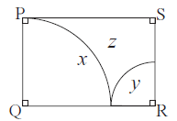

3. A chord PQ of a circle with radius 15 cm subtends an angle of 60° with the centre of the circle. Find the area of the minor as well as the major segment.

